e|d0f k|ltj]bg

gfd g]kfnL k|ltlglw d08n

sfof{no /fli6«o ;"rgf cfof]u

sfo{qmdsf] gfd 15th Edition of International Conference of Information Commissioners (ICIC)

cfof]hs Office of the Information and Data Protection Commissioners, Albania

sfo{qmd ePsf] :yfg Tirana, Albania

sfo{qmdsf] ljifo Empowering Individuals through Access to Information: Ensuring Transparency and Inclusivity in an Interconnected World

e|d0fsf] p2]Zo pNn]lvt sfo{qmddf ;xeflutf

;Dd]ng ePsf] cjlw h]7 @! b]lv h]7 @#, @)*! (3 June- 5 June 2024)

e|d0fsf] cjlw @)*! h]7 !( b]lv @% ut];Dd

;xeflu kbflwsf/Lsf] gfd k|d'v ;"rgf cfo'Qm >L dx]Gb|dfg u'?Ë,

;"rgf cfo'Qm >L sdnf cf]nL yfkf,

;lrj >L xf]d k|;fb n'O6]n,

pk;lrj >L ;Gtf]if s'df/ bfxfn,

b Plzof kmfp08]zg g]kfnsf cho s'df/ bf; .

e|d0f :jLs[lt g]kfn ;/sf/ dlGqkl/ifbsf] ldlt @)*!.)@.)# sf] lg0f{o

1. ;"rgfsf] xs ;DjGwL cfof]ux?sf] cGt/f{li6«o ;+u7g (International Conference of Information Commissioners- ICIC) sf] !% cf}+ jflif{s ;Dd]ng Information and Data Protection Commissioner, Albania n] @)*! h]7 @! b]lv @# ;Dd (3-5 June, 2024) df Tirana sf] Maritim Hotel Plaza, Tirana df cfof]hgf u/]sf] lyof] .
2. sfo{qmdsf] cl3Nnf]] lbg June 2 df ;b:o /fi6«sf k|ltlglwx?sf nflu Tirana zx/sf d]o/af6 l/;]K;g lbOPsf] lyof] . pQm cj;/df d]o/ Erion Veliaj n] lt/fgf zx/sf] Oltxf; tyf jt{dfg of]hgfsf jf/]df hfgsf/L lbb}+ ;a}hgfnfO{ :jfut u/]sf lyP . ;fy} ;"rgfsf] xs / kf/blz{tf k|lt cfkm\gf] k|ltj4tf JoQm ub}{ ;Dd]ngsf] ;kmntfsf] z'esfdgf JoQm ug'{ ePsf] lyof] . Information and Data Protection Commissioner (IDP), the national supervisory authority of the Republic of Albania sf Commissioner Besnik Dervishi n] ;a}nfO{ :jfut ug'{sf ;fy} l/;]K;gsf nflu lt/fgf zx/sf d]o/nfO{ wGojfb lbg' ePsf] lyof] . To; cj;/df ljleGg b]zsf ;"rgf cfof]usf kbflwsf/Lx?;+u e]63f6, lrghfg tyf ;Dd]ngsf jf/]df 5nkmn cj;/ ldn]sf] lyof] . d]o/sf tkm{af6 lt/fgf zx/sf] Oltxf; / ;+:s[ltsf] kl/ro u/fpg] ul/ City Walk Tour sf] cfof]hgf ul/Psf] lyof] .
3. klxnf] lbg June 03 df ;Dd]ngsf] pb\3f6g tyf ljleGg sfo{s|dx?sf] cfof]hgf ePsf] lyof] .
   1. ;Dd]ngsf] Albania sf k|wfgdGqL Edi Rama n] ;d'b\3f6g u/L z'ef/De ePsf] lyof] . k|wfgdGqLn] ;a}nfO{ :jfut ub}{ cNaflgofsf] Oltxf; tyf clxn]sf r'gf}lt / cfkm\gf] of]hgf jf/]df ljrf/ JoQm ub}{ kf/blz{tf / hjfkmb]lxtfsf nflu ;"rgfsf] xssf] dxTj /x]sf] ljrf/ JoQm ug'{ ePsf] lyof] .
   2. pb\3f6g ;qdf Information and Data Protection Commissioner (IDP), the national supervisory authority of the Republic of Albania sf Commissioner Besnik Dervishi tyf ICIC Host Authority 2024 n] :jfut / INAI d]lS;sf]sf Chairman tyf ICIC Chair Adrian Alcalá Méndez, Keynote speaker sf :yfgaf6 President of the National Anti-Corruption Authority, Italy sf Giuseppe Busia / Judge of the European Court of Human Rights sf Darian Pavli n] ;"rgfsf] xssf jf/]df dGtJo /fv]sf lyP .
   3. sfo{qmddf b]xfo adf]lhdsf Panel Discussion x? ePsf lyP / k|:t't sfo{kqdf uxg 5nkmn ePsf] lyof] . o; cj;/df ;xefuLx?n] cfcfkm\gf] cg'ej, lh1fzf tyf ;'emfj k|:t't u/]sf lyP .
      1. Empowering Vulnerable Groups through Access to Information and Transparency.
      2. Role of civil society and media in promoting access to information and transparency
      3. Proactive transparency through digital tools and open data initiatives
      4. Striking proper balance between ATI and data protection rights in the digital realm. How can we protect citizens’ personal data while making efforts on ensuring digital information rights?
      5. UNESCO panel: Mid-way through the implementation of the 2030 Agenda: Monitoring and Reporting on SDG 16.10.2
   4. klxnf] lbg g} ;"rgf cfo'Qmx?sf] If]qLo a}7sx? klg ;DkGg ePsf lyP . If]qLo a}7sdf cfcfkm\gf] If]q leq kg]{ b]zsf ;"rgf cfo'Qmx? a;L cfufdL lbgdf ;"rgfsf] xsnfO{ yk k|efjsf/L agfpg s;/L ;+o'Qm k|of; ug{ ;lsG5 eGg] jf/]df 5nkmn ePsf] lyof] . g]kfn If]qLo ;+u7gdf ;b:o gePsf] sf/0faf6 ko{j]Ifssf ?kdf dfq ;xefuL ePsf] lyof] .
      1. African Network of Information Commissions
      2. Transparency and Access to Information Network
      3. European Network
      4. Asian Access to Information Alliance
      5. North America Network
4. bf];|f] lbg
   1. ljutsf a}7sx?af6 u7g ePsf $ j6f Working Group x?sf sfo{ k|ultsf] hfgsf/L / ;dLIff k|:t'lt x'g'sf ;fy} sfo{kqx?df 5nkmn ePsf] lyof] . ;d'xx?n] tof/ kf/]sf k|ltj]bg tyf k|ltj]bgn] lbPsf ;'emfjx?sf jf/]df ;3g 5nkmn ePsf] lyof] . ;'emfjx? ;"rgfsf xssf If]qdf cfufdL lbgdf ;a} ;"rgf cfof]ux?n] nfu' ub}{ hfg pkof]uL x'g] vfnsf 5g . s]lx ;d'xsf ;'emfjx? cg';'rLdf /flvPsf 5g .
      1. Transparency by Design Working Group, presented by Warren Seddon, ICO FOI Director and Cibelle Brasil, Access to Information Director, Brazil
      2. Training Working Group - Digital Training Platforms Report, presented by Blanca Lilia Ibarra Cadena, INAI Commissioner, Mexico
      3. Law cases Working Group - Relevant Cases Report, presented by Adrián Alcalá Méndez, INAI President Commissioner, Mexico
      4. Gender and People in Vulnerable Situations Working Group, presented by María Gracia Andía, Head of ATI Guarantor Body, Buenos Aires
   2. bf];|f] lbg g} ICIC sf] casf] /0fg}lts sfo{lbzf s] x'g], ;"rgfsf] xssf lgofdsx?sf r'gf}ltsf jf/]df Future of the ICIC conference: What is next for information regulators? What are our common challenges and where should the ICIC work focus in the future strategic direction? ljifos Kofgn 5nkmn ePsf] lyof] . pQm cj;/df b]xfosf ljrf/x? JoQm ePsf lyP .
      * ICIC nfO{ :jtGq / cfTdlge{/ ;+u7gsf] ?kdf ljsf; ul/g'kb{5 .
      * ICIC n] w]/} d'n'sdf dfgj clwsf/ ;+/If0fdf dxTjk'0f{ e'ldsf v]n]sf] 5,
      * ljZjJofkL ?kdf p7]sf] d"n d'4fsf] ?kdf /x]sf] Disinformation, Misinformation / Hate Speech nfO{ lg?T;flxt ug{ ICIC n] eljiodf dxTjk'0f{ e"ldsf lgjf{x ug'{kg]{ x'G5,
      * Digital Plateform sf] k|of]u a9fpg'kg]{,
      * /fhg}lts OR5fzlQm ljgf dfgj clwsf/sf] ?kdf /x]sf] ;"rgfsf] xssf] k|efjsf/L sfof{Gjog ;Dej g/x]sf],
      * o'jf hgzlQm ;"rgfsf] xssf ljifodf hfu?s / ;+nUg x'g' kb{5,
      * ICIC sf] cfly{s Jooef/sf] ljifodf >f]t h'6fpg] ;+ul7t k|of; ul/g'kg]{,
      * ;"rgf cfo'Qmx?nfO{ ;xof]usf] nflu cfwf/e't ;+oGq cfjZos /x]sf] ;fy} sltko b]zdf sfg"g adf]lhd ;"rgf cfo'Qmx? lgo'Qm x'g g;s]sf],
      * ICIC nfO{ ;jn agfpg ;a} d"n's ;Fu;Fu} cufl8 a9\g'kg]{,
      * ICIC n] ;"rgf cfo'Qmx?sf] cfjfhnfO{ cGt/f{li6«o:t/af6} p7fpg' kb{5 .
   3. bf];|f] lbg g} June 4 df Tirana sf] P]ltxfl;s zx/ Kruja df ;f+:s[lts e|d0f cfof]hgf ul/Psf] lyof] .
5. t];|f] lbg ;b:o /fi6«x?sf k|ltlglwx? dfq ;xefuL ePsf] aGb ;q -sfo{s|d ;+nUg 5_ ;~rfng ePsf] lyof] .
   1. aGb;qdf b]xfo adf]lhdsf If]qLo k|ltj]bgx? k|:t't ePsf lyP . o; k|:t'ltdf ljleGg b]zsf ;"rgf cfof]ux?n] ut cfly{s jif{df u/]sf pNn]vlgo pknJwL tyf cg'ejx? /flvPsf lyP . o;af6 ;"rgfsf] xs sfo{Gjogsf If]qdf k|of]u ePsf g‘of / /fd|f sfo{s|dx?sf jf/]df hfGg] / l;Sg] cfj;/ k|fKt ePsf] 5 .
      1. Africa Presented by: Pansy Tlakula, Chairperson, Information Regulator of South Africa.
      2. Asia Presented by: Philippines
      3. Europe Presented by: Martina Schloegel, Head FOI Department and Johannes Otremba Senior Legal Officer, Federal Commissioner for Data Protection and Freedom of Information, Germany.
      4. Latin America Presented by: Blanca Lilia Ibarra Cadena, INAIs Commissioner, Mexico
      5. North America and Caribbean Presented by: Alina M. Semo, Director, Office of Government Information Services, United States of America; Caroline Maynard, Commissioner, Office of the Information Commissioner of Canada; and Gitanjali S. Gutierrez, Information Commissioner of Bermuda.
      6. Oceania Presented by: Elizabeth Tydd, Freedom of Information Commissioner, Office of the Australian Information Commissioner and Emma Leach, Senior Assistant Ombudsman Strategy and Development, New Zealand Office of the Ombudsman.
   2. INAIs Commissioner Blanca Lilia Ibarra Cadena af6 ICIC Chair Report 2021-2024 k|:t't ePsf] lyof] . k|ltj]bgdf ;g @)@! b]lv @)@$ ;Dd ICIC n] u/]sf dxTjk'0f{ s[ofsnfkx? ;d]l6Psf 5g .
   3. ICIC sf] !& cf}+ ;Dd]ng ug{ l;o/f lncgsf] ;"rgf cfof]un] u/]sf] k|:tfj cg';f/ ICIC sf] sfo{;ldltn] 5nkmn u/] cg'?ksf] k|:tfj k|:t't ePsf] lyof] . pQm k|:tfj :jLst ePsf] lyof] . o;af6 ICIC sf] !& cf}+ ;Dd]ng l;c/f lncgdf x'g] lglZrt ePsf] 5 .
   4. ICIC sf] sfo{;ldltn] o; ;Dd]ngsf] Public Statement k|:tfj u/]sf] / ;b:ox?af6 k|fKt ;'emfj cg'?k -g]kfnn] klg ;+;f]wg k|:tfj u/]sf]df x'ax' kl/dfh{g ePsf]_ kl/dfh{g ul/Psf] “Transparency and digital age: the information commissioners’ role and citizen empowerment” gfds Public Statement :jLs[t u/]sf] / ;fj{hlgs ePsf] 3f]if0ffkq o;};fy ;+nUg 5 .
   5. aGb;qdf g} g]kfnsf tkm{af6 Role of Civil Society sf ;DaGwdf Working Group agfpg] k|:tfj / ;fpy clk|msfsf tkm{af6 k|:tfj ePsf] Information Integrity df Working Group agfpg] ljifodf 5nkmn ePsf] lyof] . k|:tfj eP cg'?k b'Oj6f Working Group agfpg] ljifo ;dfj]z u/L /0fg}lts of]hgf agfpg nfluPsf] 5 .
   6. ;Dd]ngsf] !^ cf} ;Dd]ng Federal Commissioner for Data Protection and Freedom of Information in Germany sf] cfof]hgfdf hd{gLdf ug]{ jf/]df utjif{ g} lg0f{o eO{;s]sf] 5 .
   7. ;Dd]ng z'? x'g' eGbf cufa} g]kfnn] Online sf] dfWodaf6 ICIC sf] ;lrjfno cWoIf / sfo{sfl/0fL ;ldltsf ;b:osf] nflu dtbfg u/]sf]df cWoIfdf d]lS;sf] / sfo{sfl/0fL ;ldlt ;b:odf ci6«]lnof / s]Gof lgjf{lrt ePsf] hfgsf/L a}7sdf hfgsf/L u/fOPsf] lyof] . ICIC sf] sfo{;ldltsf] cWoIfdf k'g cfufdL ltg jif{sf nflu d]lS;sf]sf] Federal Institute for Access to Public Information and Data Protection (INAI) /xg] ePsf] 5 .

1. sfo{qmddf ;b:o /fi6«sf ;"rgf cfof]usf k|d'v tyf cGo k|ltlglwx?sf] ;xeflutf /x]sf] lyof] . ;b:o /fi6« Pj+ ;+3;+:Yff / bft[lgsfo ;d]t u/L sl/j !@) hgf k|ltlglwsf] pQm ;Dd]ngdf ;xeflutf /x]sf] lyof] .
2. ;Dd]ng pknlAwd'ns /x]sf] lyof] . ;Dd]ngaf6 l;Sg] / l;sfpg] tyf gofF cj;/x?;Fu kl/lrt x'g] cj;/ ldn]sf] 5 . sltko ljifox? cyf{t Panel Discussion, Regional Presentation tyf cGo k|:t'lts/0f / 5nkmnaf6 g]kfnn] l;Sg] cj;/ k|fKt u/]sf] 5 . o:tf l;sfO{x? cfufdL lbgdf agfOg] /0fgLlt tyf sfo{of]hgf / sfo{s|ddf ;dfj]z ub}{ hfg ;lsPdf g]kfndf ;"rgfsf] xssf] sfo{GjognfO{ yk k|efjsf/L agfpb} hfg] ;lsg] ljZjf; lnOPsf] 5 . Working Group x?n] l;kmfl/z u/]sf ljifox? g]kfnsf nflu cToGt dxTjk'0f{ /x]sf 5g . b'O{j6f Workign Group df g]kfn klg ;b:o /xL dxTji'0f{ of]ubfg lbg ;kmn ePsf] 5 . ;fy} ;Dd]ngsf s|ddf g]kfnsf tkm{af6 ePsf x:tIf]kx?nfO{ ;Dd]ngn] ;s/fTds ?kdf lnPsf] / lg0f{odf klg ;dfj]z u/]sf] 5 .
3. g]kfnsf tkm{af6 ;Dd]ngdf g]kfnnfO{ bL3{sflng c;/ kg]{ s'g} k|ltj4tf JoQm gePsf] . t/ g]kfnn] o; ;+u7gdf b]vfPsf] ;lqmotfaf6 o;sf] g]t[Tj lng ;Sg] ;Defjgf k|jn b]lvG5 . o;sf nflu g]kfn ;/sf/sf] ;xdlt tyf ;|f]t ;fwgsf] Joj:yf x'g cfjZos x'G5 . o;sf] :yfoL sfof{no gePsf] x'Fbf cWoIftf ug]{ b]zn] Ps jif{;Dd ;lrjfnosf] sfo{ / ;Dd]ngsf] cfof]hgf ug'{kg]{ x'FG5 . o;af6 g]kfnnfO{ cfly{s, ko{6sLo tyf s"6gLlts ?kdf kmfObf k'Ug] b]lvG5 .

cg';"rL

Gender and People in Vulnerable Situations Working Group

Recommendation:

* To create participatory strategies so that GVSs and women targeted by ATI policies participate in their creation and design.
* To collect and systematize more information on how GVSs and women exercise the right of ATI.
* To generate instances of closeness with GVSs and women in order to strengthen trust and shorten the distance between them and the State.
* To develop ATI practices accessible to people with disabilities.
* To ensure that the guides for accessing public information and other pertinent materials are translated into the languages of indigenous peoples and ethnic minorities present in the jurisdictions, and that they are written in clear language.
* To conduct training on gender perspective and GVSs for people who work in ATI systems in each of the jurisdictions.
* To forge alliances with social leaders, human rights defenders and civil society organizations that promote the rights of GVSs and women, in order to expand knowledge about the exercise of the right of ATI and its possibilities.
* To provide specialized advice to GSV members in submitting ATI requests.
* To monitor and evaluate the policies of access to information for women and GVSs.

Transparency by Design Working Group

Based on the promising practices and experiences identified and the challenges to their implementation reported by the surveyed authorities, the WG presents the following recommendations:

* Online portals are conducive to greater openness which, in turn, facilitates the fight against corruption;
* Maximum transparency should be the general rule whilst secrecy is the exception;
* Regulators should be equipped with the relevant powers to ensure compliance with the law and have the ability to exercise these powers effectively;
* Concerted efforts, cross-sectoral collaboration and establishing synergistic relationship with relevant stakeholders is key;
* Citizens and civil society should be an integral part of the decision-making process, including at local and municipal level;
* Leveraging the benefits of secure and sustainable technology can help streamline access to information processes;
* Building access and inclusion into access to information process to minimise the risk of exclusion of certain groups. To this end, one respondent highlighted that knowing applicant’s sociodemographic characteristics could be helpful to enable the removal of barriers to access;
* The publication of regulators’ decisions should be timely to ensure both public bodies and applicants have visibility of the latest decisions on any specific issue;
* Need to ensure that information in high demand is made proactively available in a clear language and in formats applicants can access. For example by being mindful of the risk of digital exclusion.

;Dd]ngsf s]xL tl:j/x?

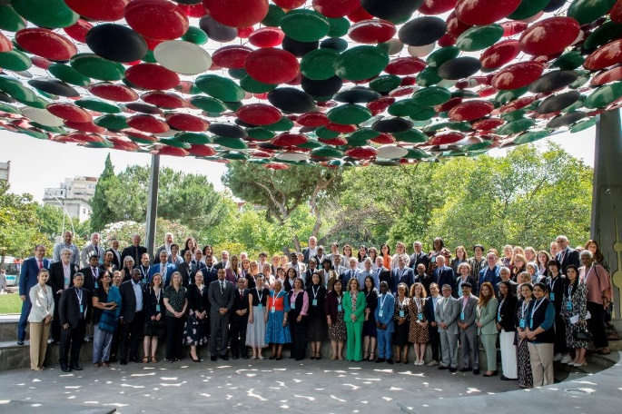

;Dd]ngsf ;xefuLx?sf] ;fd'lxs kmf]6f]

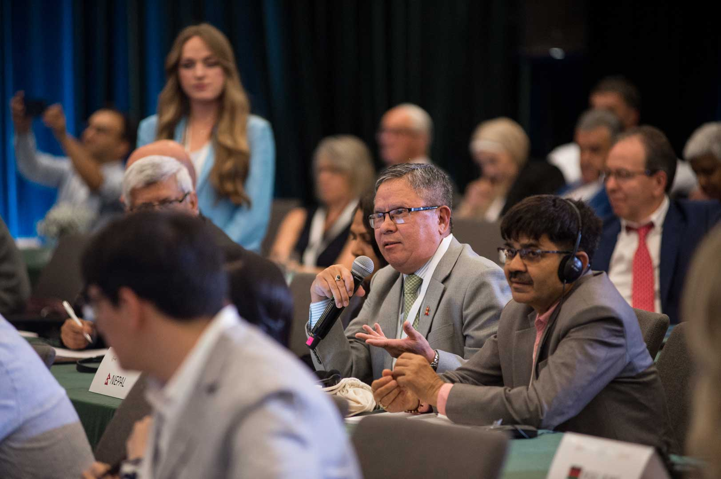

;Dd]ngdf cfkm\gf] ljrf/ JoQm ub}{ k|d'v ;"rgf cfo'Qm dx]Gb| dfg u'?Ë / ;lrj xf]d k|;fb n'O6]n

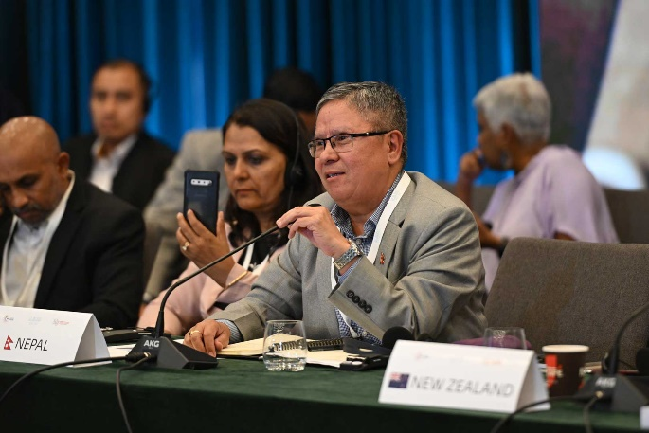

aGb;qdf cfkm\gf] ;'emfj /fVb} k|d'v ;"rgf cfo'Qm dx]Gb| dfg u'?Ë / ;"rgf cfo'Qm sdnf cf]nL

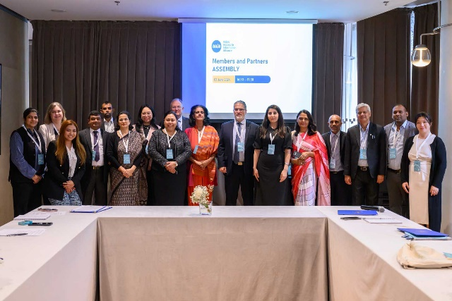

If]qLo a}7sdf ;xefuL x'+b} ;"rgf cfo'Qm sdnf cf]nL / pk;lrj ;Gtf]if bfxfn

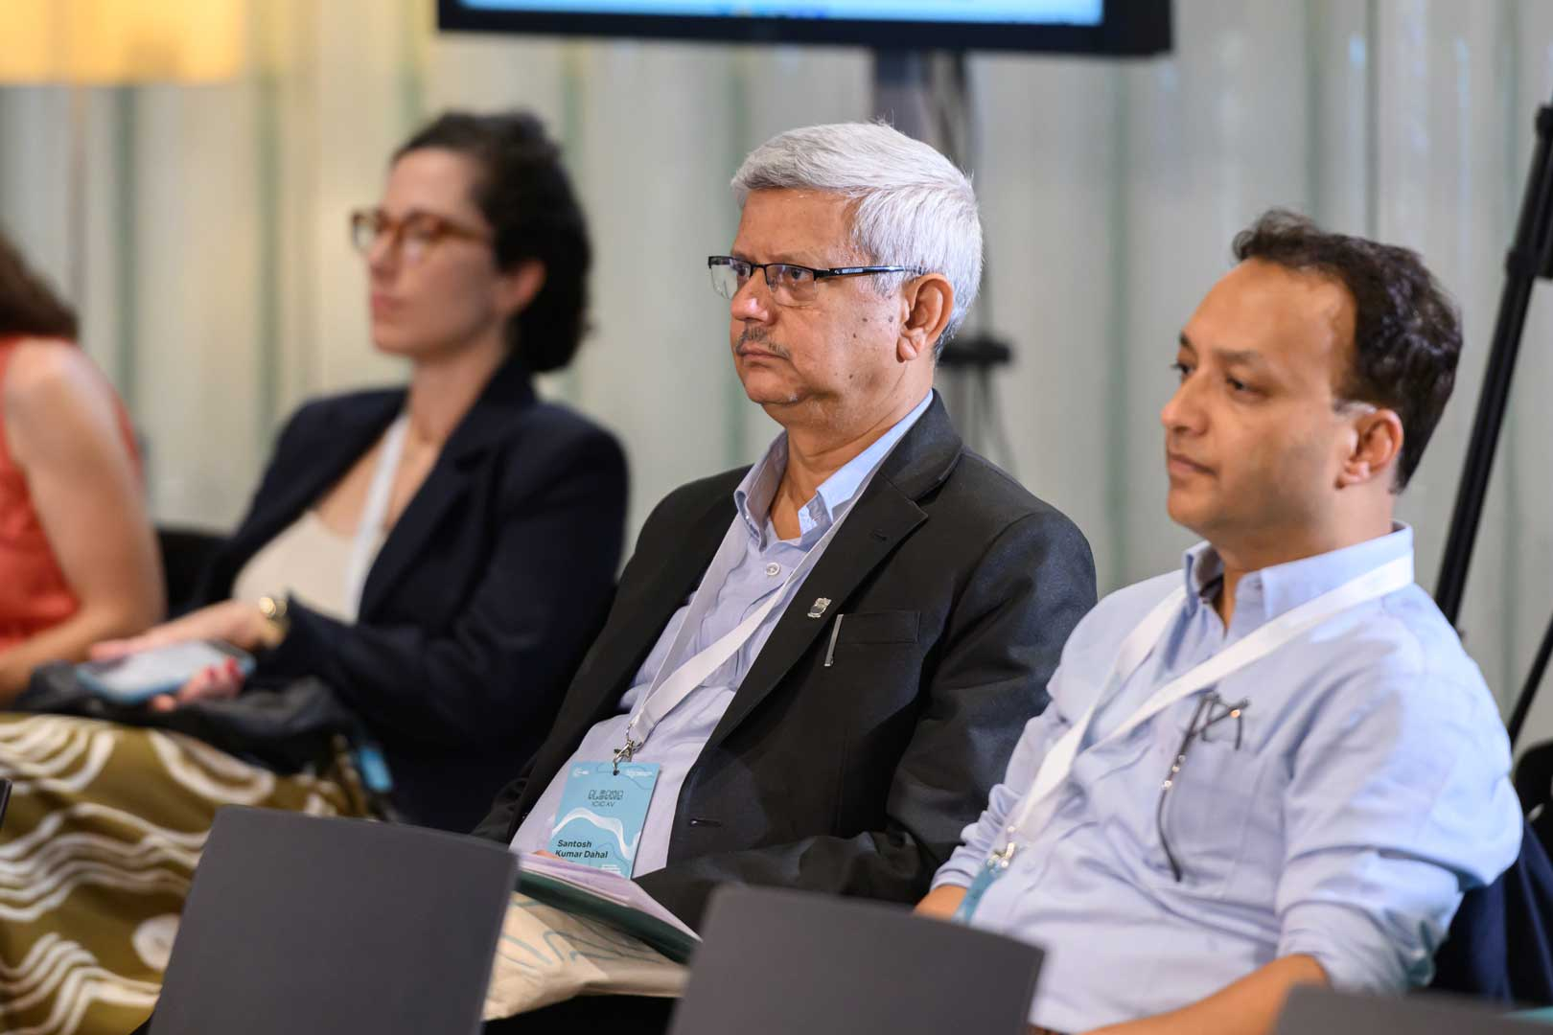

;Dd]ngdf ;xefuL pk;lrj ;Gtf]if bfxfn / Plzof kmfp08]zgsf cho bf;

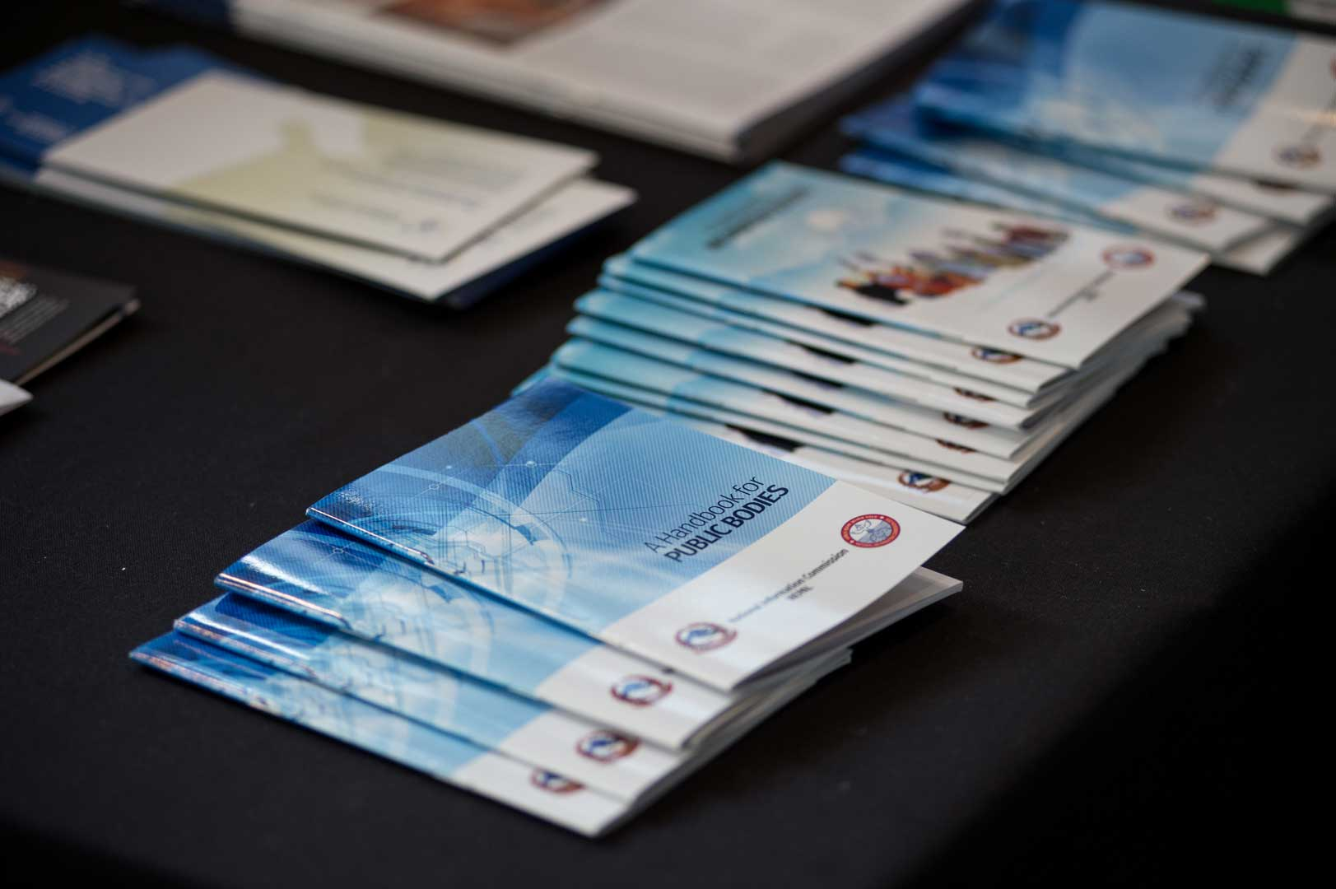

;Dd]ngdf cfof]usf a'n]l6g / ;xof]uL k'l:tsf ljt/0fdf